Unit Test Evidences

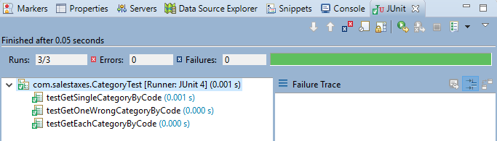

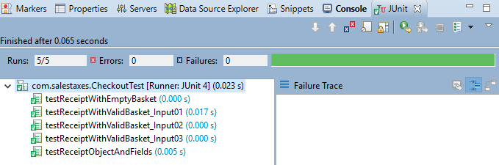

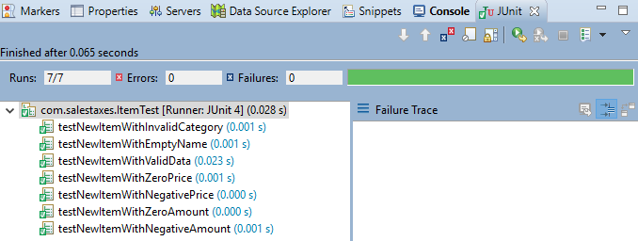

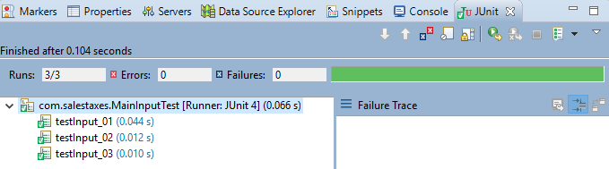

Maven Build

